Output Screenshots:

Main.html(NJIT Registration System):

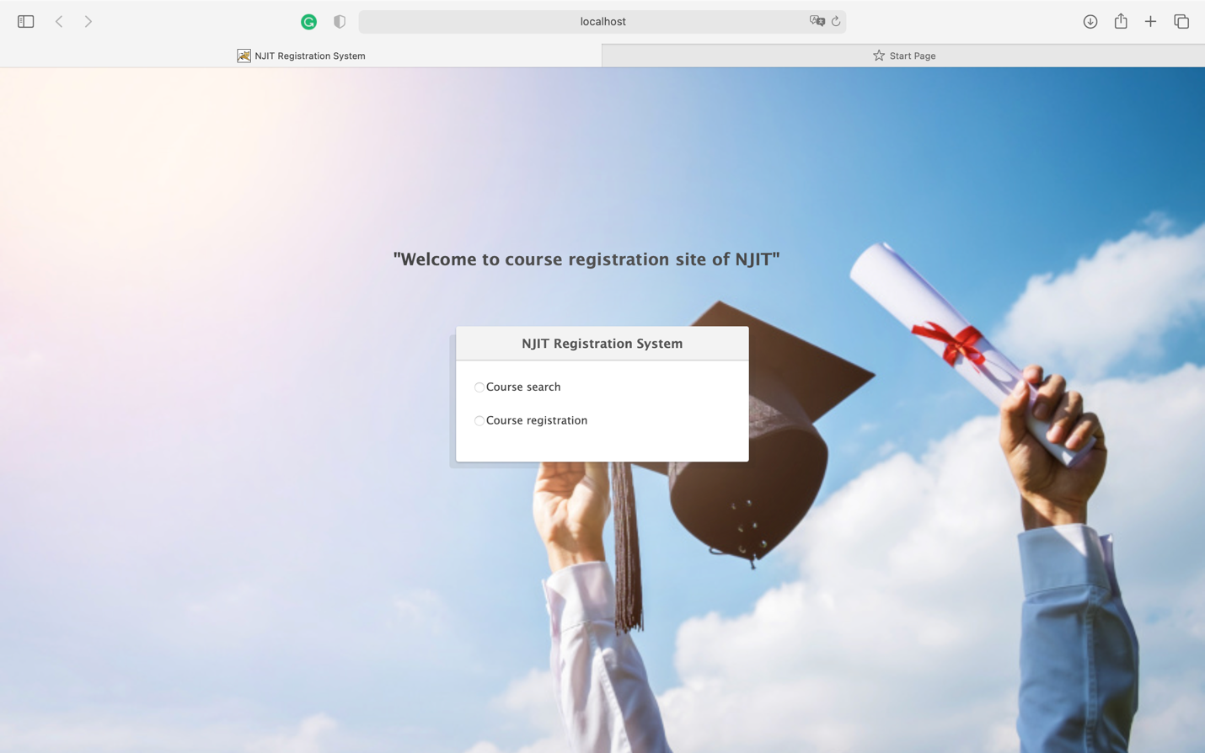

Course Search page:

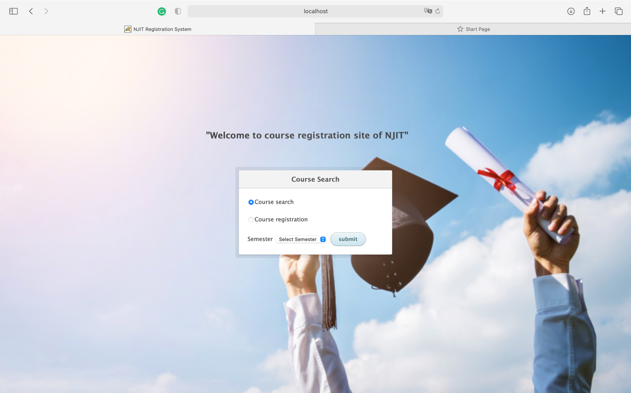

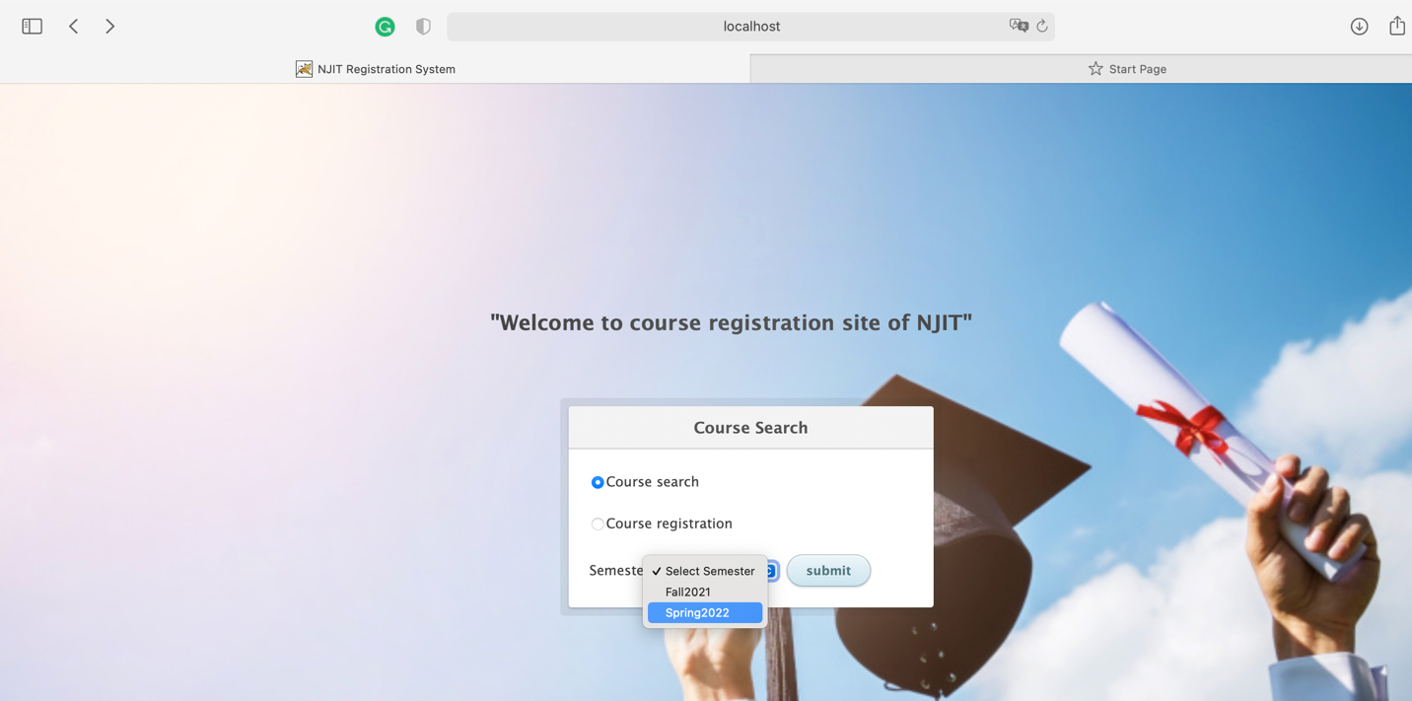

Successful Course Search For Fall2021 semester:

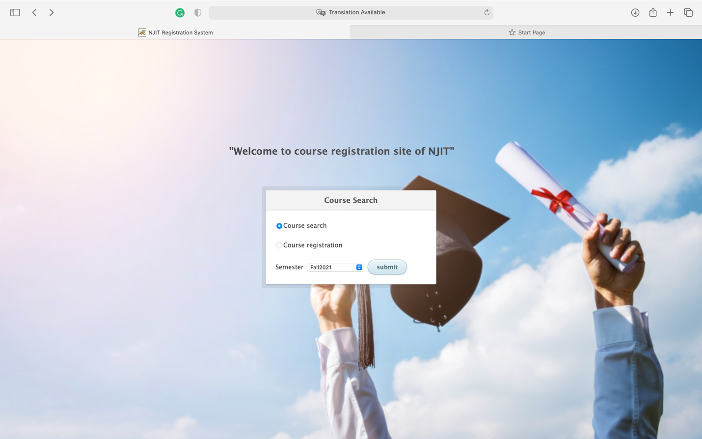

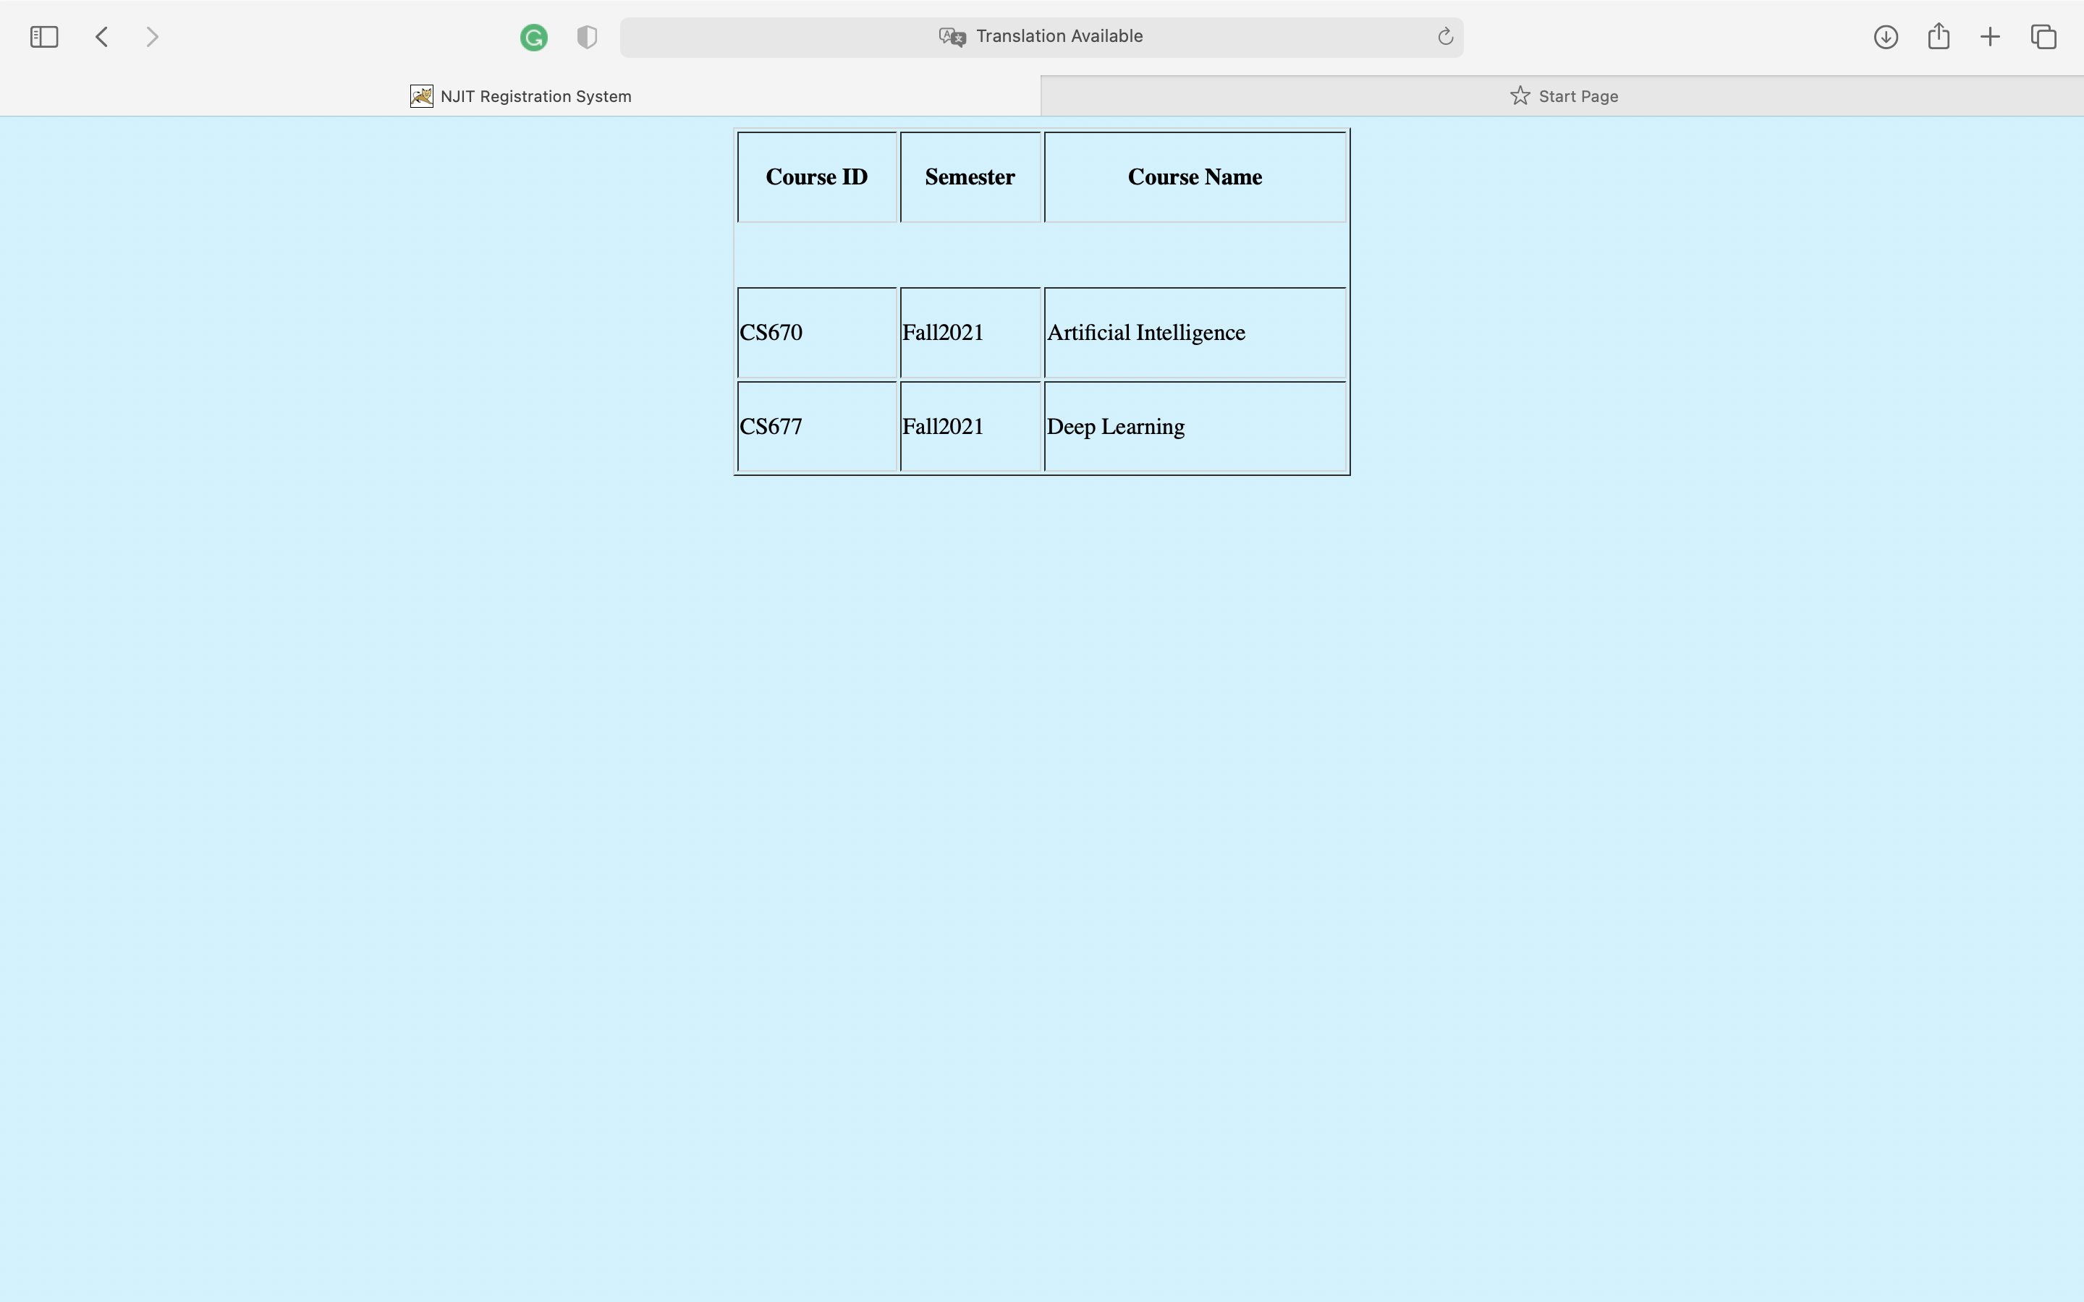

Successful course search for Spring 2022 semester:

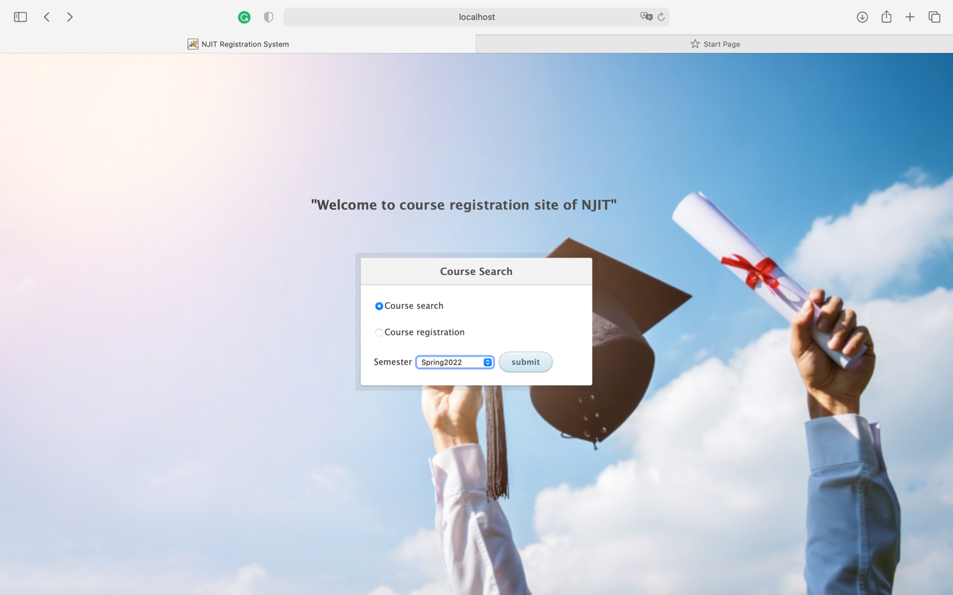

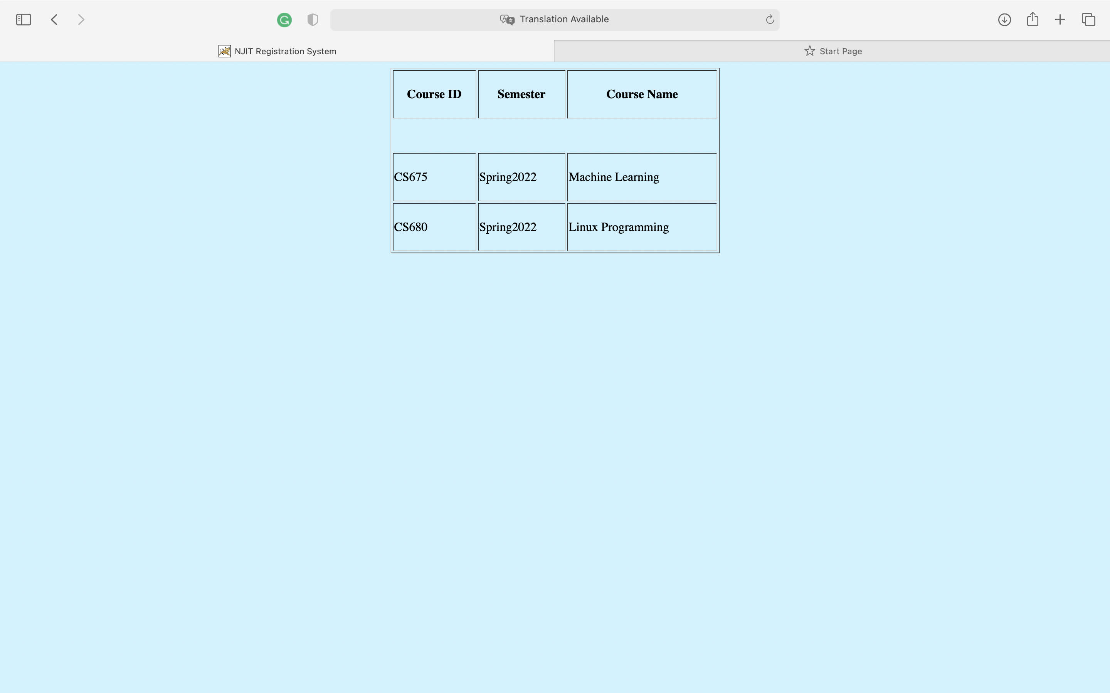

Unsuccessful course search for empty input:

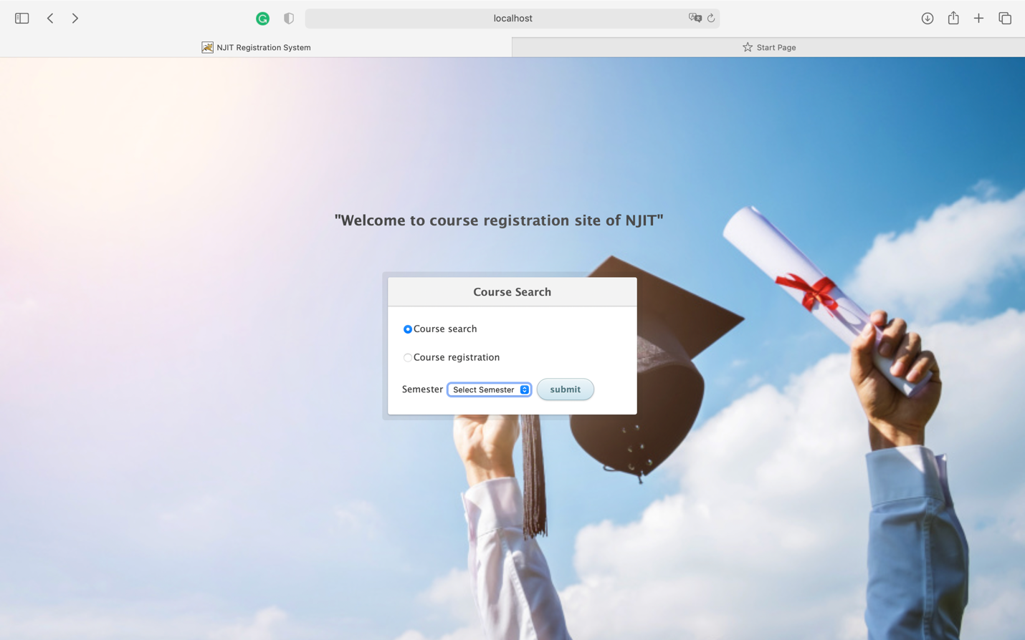

(Note: as instructed this query is failed from the database side, & is not handled, instead reflected with the appropriate warning message. (Also exception message is printed on console))

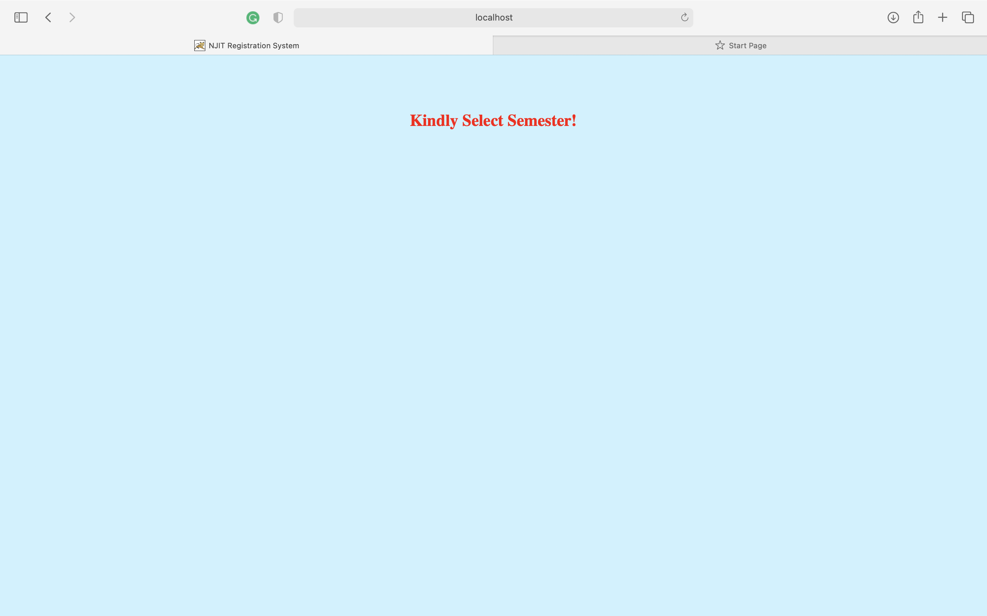

Course Registration Page:

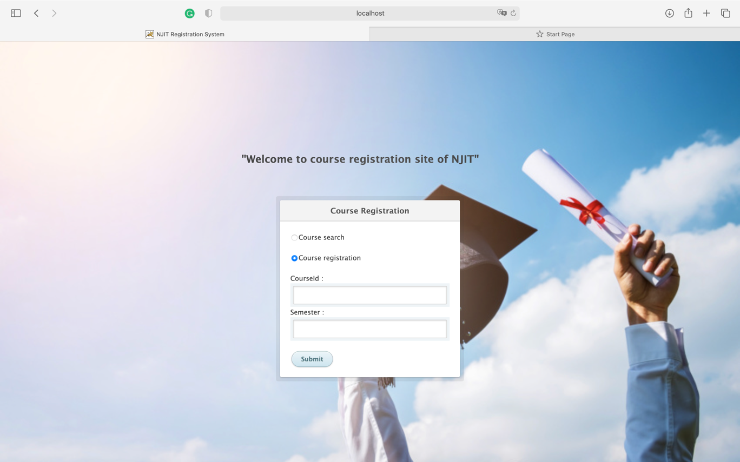

Unsuccessful submission for course registration due to empty input in one or more input field:

(Note: as instructed this query is failed from the database side, & is not handled, instead reflected with the appropriate warning message. (Also exception message is printed on console))

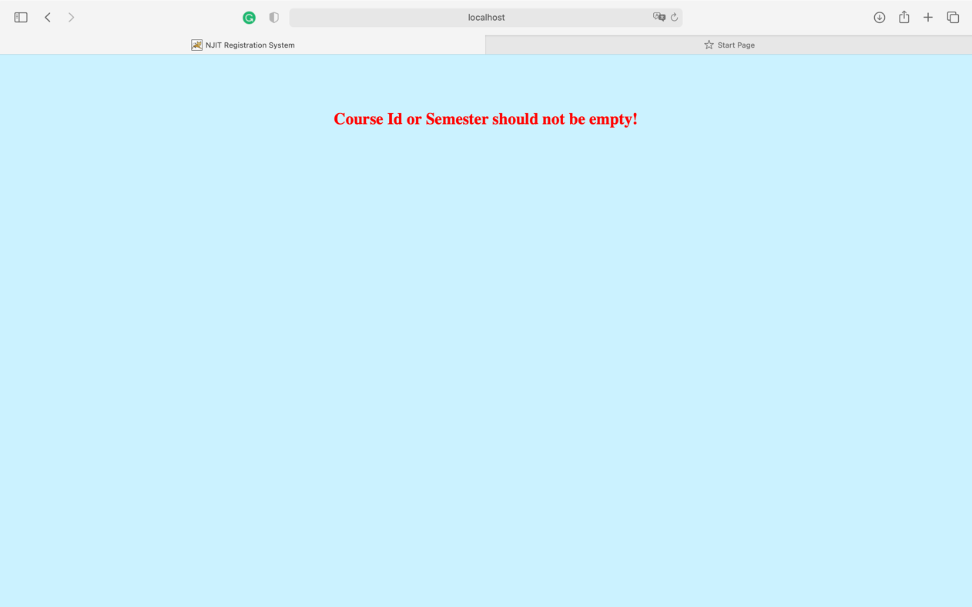

Successful Course Registration for CS670:

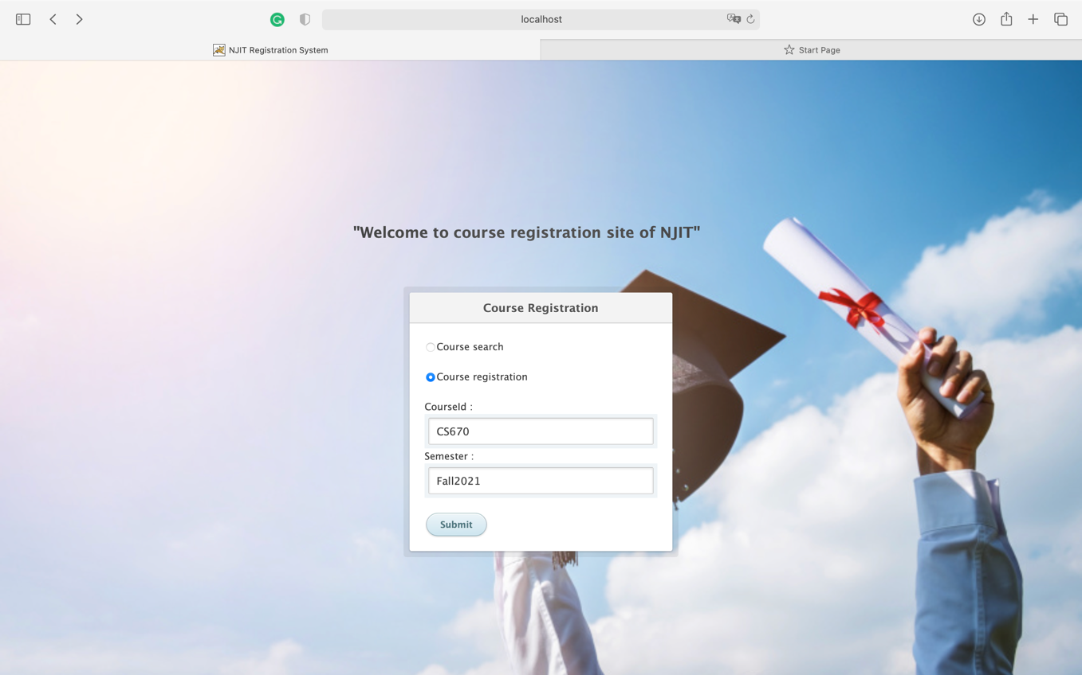

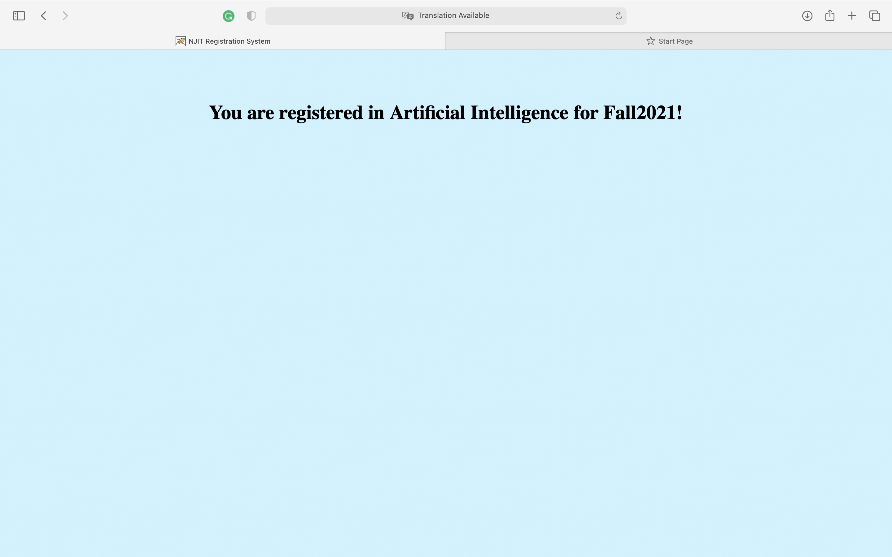

Unsuccessful course registration as the course is not available in the database:

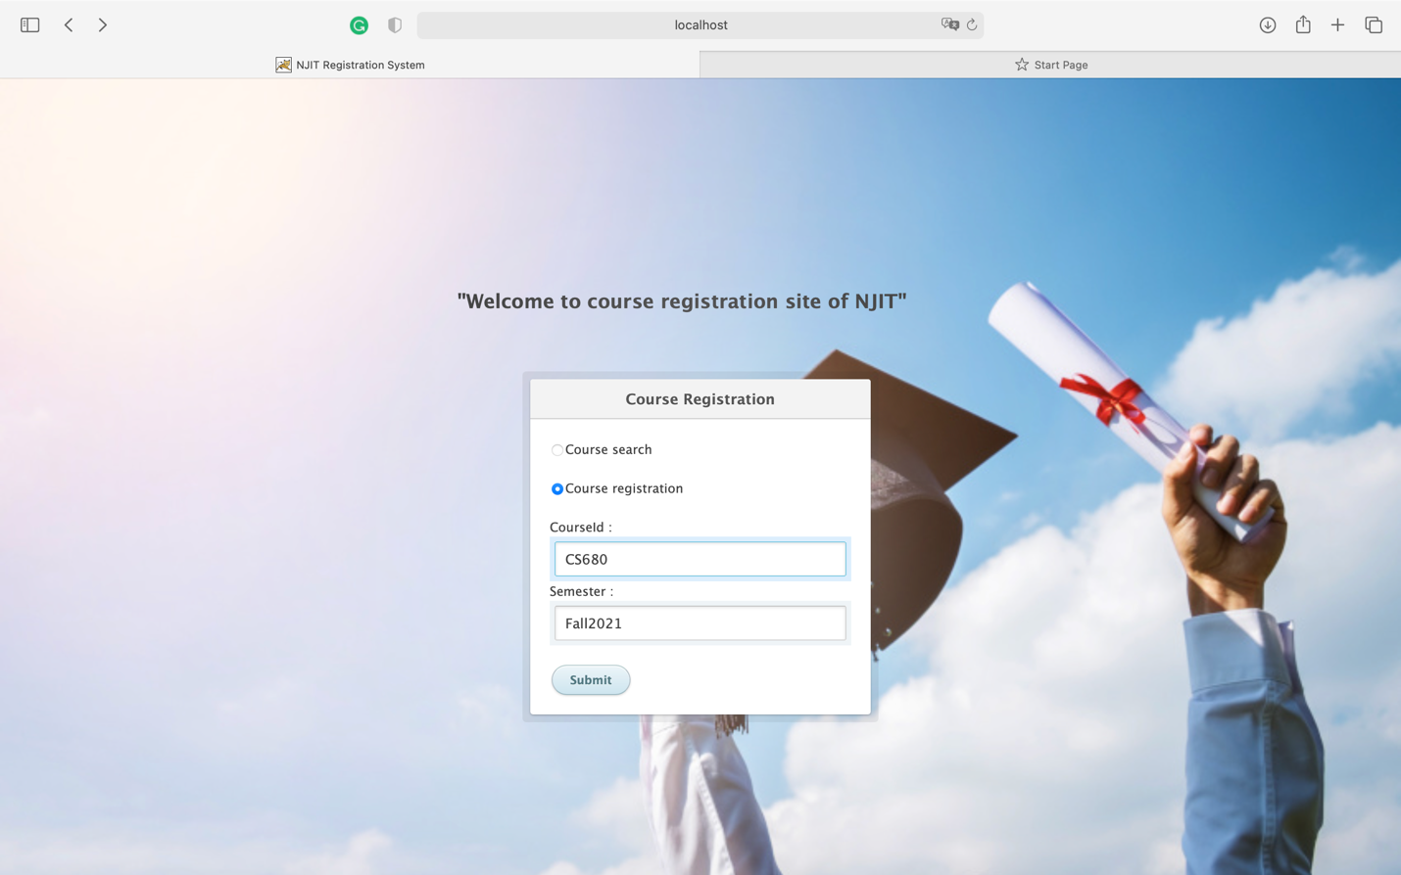

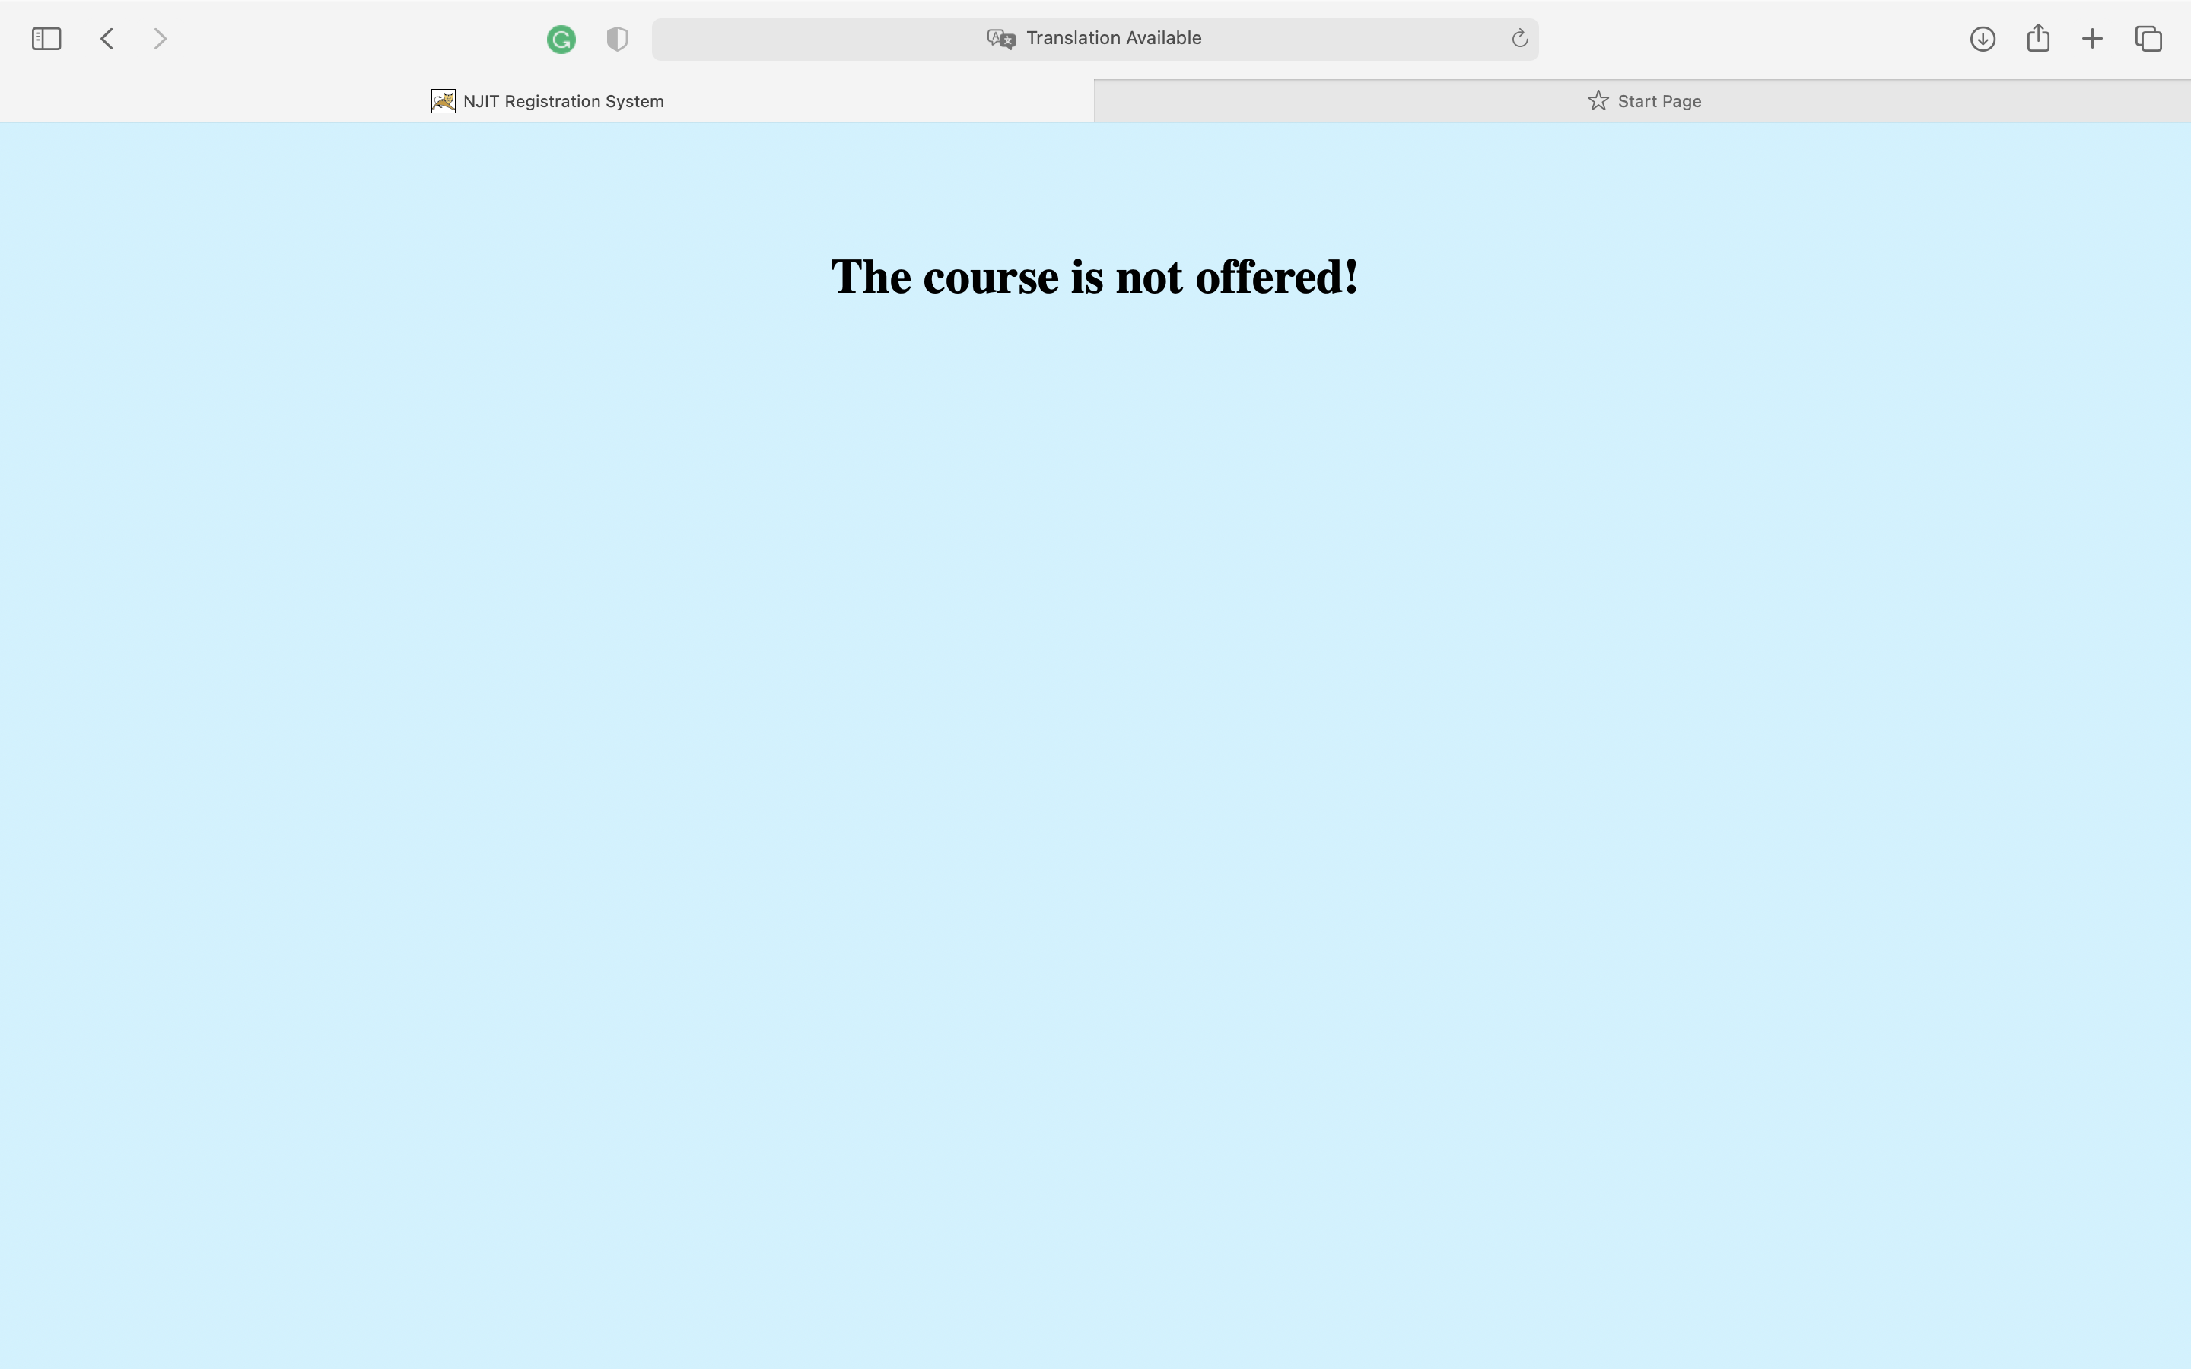

Successful Course registration:

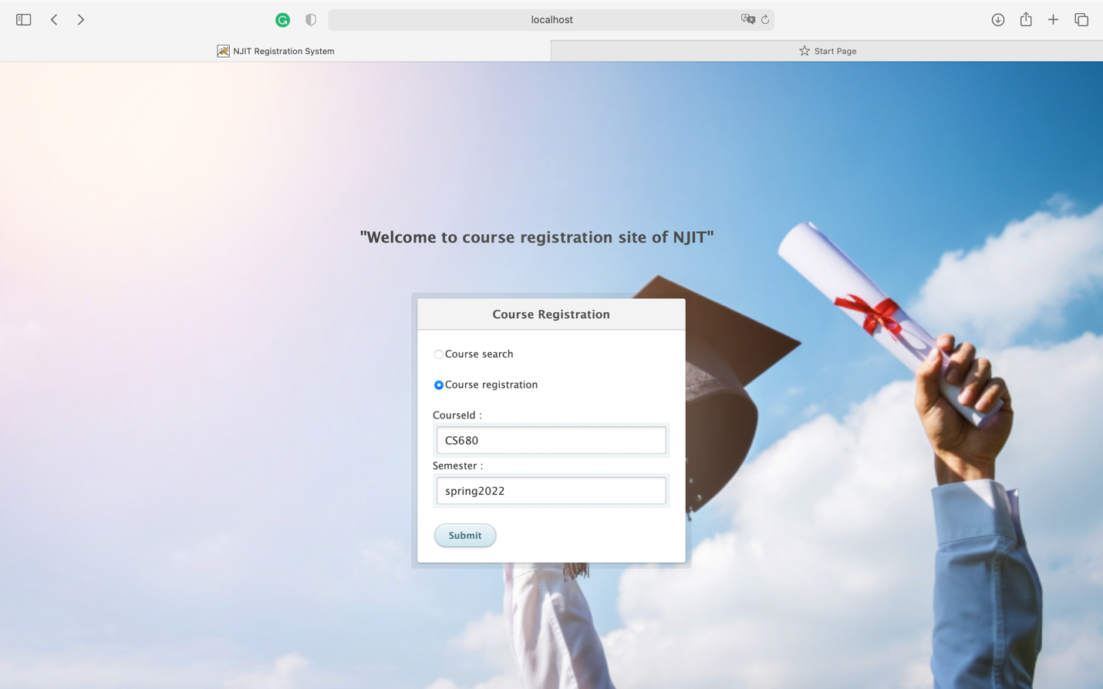

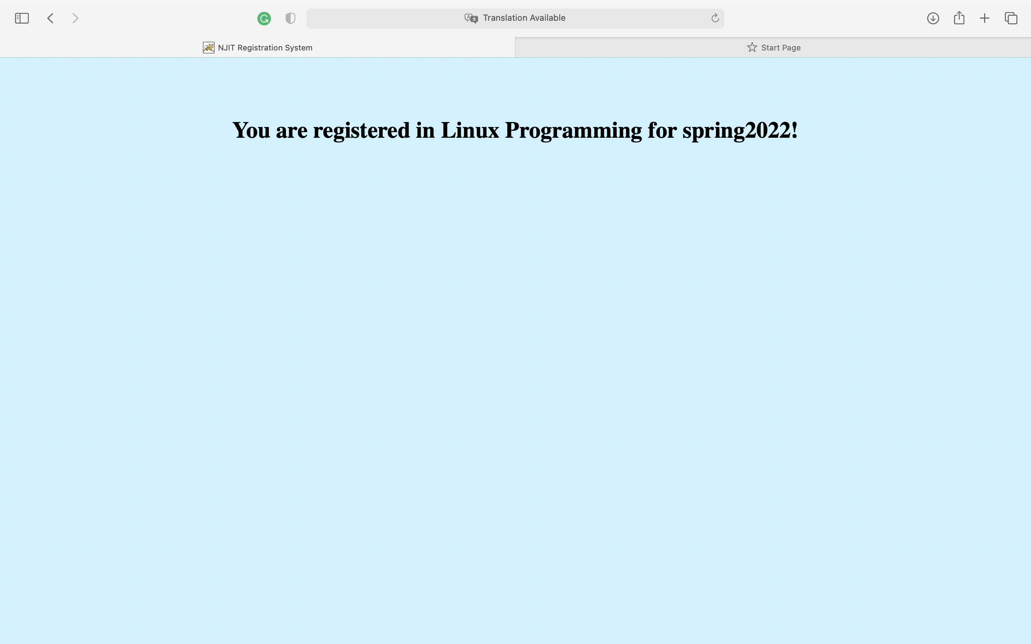

Database screenshot:

Select \* from courses;

